**A Guidebook to IOS Jailbreaking**

By: Noah Hendricks

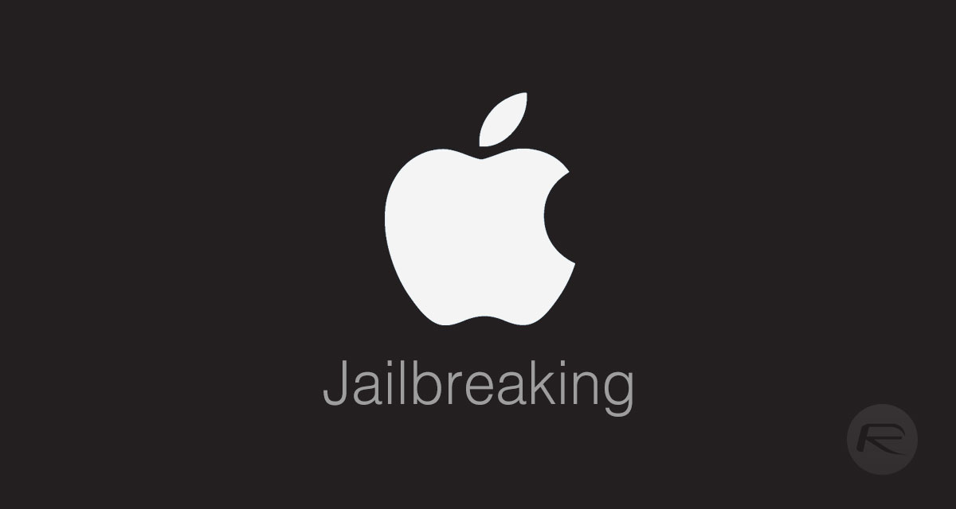

Table of Contents

**Introduction** 3

**What is Jailbreaking?** 4

**Legality of Jailbreaking** 4

**IOS Jailbreak History** 5

**Personal Experience** 6

**Jailbreak Pros** 7

Download and Use of Third-Party Apps 7

Cross Compatible File Sharing 8

Special Customization of IOS Device 8

Remove Pre-Installed Apps 9

**Jailbreak Cons** 9

Invalidate iPhone Warranty 9

Apple’s Software Security Terminated 10

Inability to Update IOS Device 10

Drained Battery Life 11

Increased Device Crash Rate 11

Disruption of Services 12

**Jailbreak Instructions** 12

Step by Step Guide 16

YouTube Attachment 17

**Conclusion** 18

**References** 19

# **Introduction**

IOS Devices are swiftly on the rise and have been the new norm of society for over the past decade. These devices include Apple’s iPod Touch, iPad, and most importantly iPhone. Apple’s multiple versions of the MacBook and even Apple TV’s can also be jailbroken, but they have different Operating Systems which differ from IOS. Therefore, we will only be talking about the devices which use the iPhone Operating System. Jailbreaking is such an extreme and out of the norm feature that many IOS users are intrigued by and want to display on their devices. Because jailbreaking is such an incredible tool, many IOS users jump right into it without really knowing what they are risking to their device. Although there are many neat things that come along with IOS jailbreaking, there are also many risky consequences. In this handbook, I will talk all about IOS jailbreaking including its’ history, what it is and does, its’ pros and cons, its’ legality, and a step by step guide on how to actually do it.

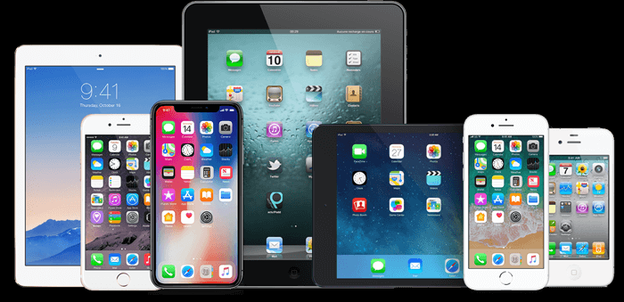

# **What is Jailbreaking?**

In layman’s terms, jailbreaking is the process of releasing all restrictions from your device’s rules, processes, and set of policies that it is designed to listen to and follow at all times. In this case, IOS jailbreaking is to release the IOS device from all instruction sets designed by Apple or phone carriers that the device is structured to follow. Furthermore, this process allows the user to do many things that they originally were unable to access. For example, jailbroken devices offer special customization features, alternative downloadable applications, free apps that may have originally required purchase, and just a multitude of things and alternate features that IOS initially had confined.

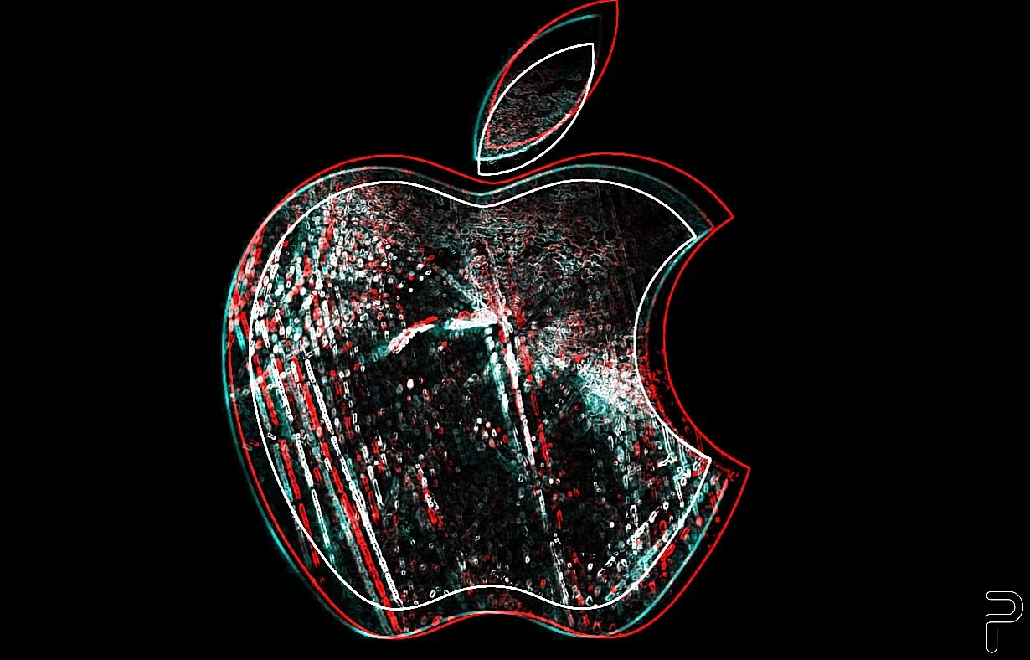

# **Legality of Jailbreaking**

There is a huge underlying question that many IOS users are confused about and do not really know the straightforward answer to the legality of jailbreaking. In short, yes jailbreaking your IOS Device is totally legal and does not break any specific laws. However, it is illegal in some countries, but the United States is not one of them. In contradiction, Apple does have a policy that might violate the IOS User End Agreement if are tampering with your jailbroken device. Moreover, it is illegal to jailbreak a phone and gain illegally acquired apps. Although jailbreaking an IOS Device itself is not illegal, if you use it for the wrong reasons it is 100% illegal.



# **IOS Jailbreak History**

Jailbreaking within the IOS devices began shortly after this Operating System was released to the public way back in 2007. It all started with a 17-year-old boy named George Hotz who apparently wanted to use his iPhone with a different phone carrier. He was able to hack into the hardware of the first-generation iPhone with only a screwdriver and a guitar pick. In doing this, he was able to get to the device’s processor, where he was then able to unlock his iPhone service carrier by scrambling the baseband’s code. Following this act by George, the birth of Cydia, the gateway of installing jailbroken apps, was born. In essence, he took full control of his device and in doing this, he singlehandedly began the revolution of jailbreaking IOS Devices.

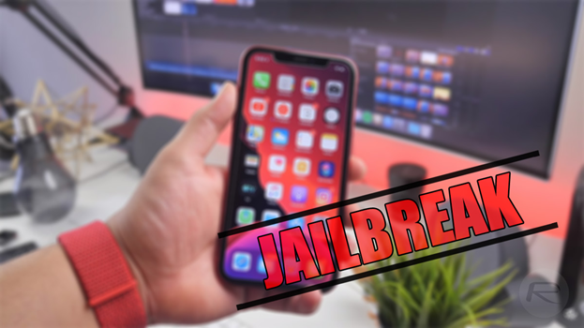

# **Personal Experience**

My first experience with an IOS Device was the original iPod Touch. It was my first touch screen device that had internet capability. I thought It was the coolest thing back then and went on to do many things with it like surf the web, listen to music, watch movies, and much more. Furthermore, I eventually got bored with my device and discovered the power of the jailbreak process and all it has to offer. In fact, I jailbroke my device the same day I found out what it was, and I was so excited. But little did I know the aftermath of my actions and how much harmful exposure I had just caused to my first IOS Device. Soon after I jailbroke my iPod Touch, software bugs started to form, my device would run super slow and die in such a short period of time, apps would crash often and unexpectedly, and the worst thing was all the malware I just let breach my device because it no longer had Apple’s software security protection.

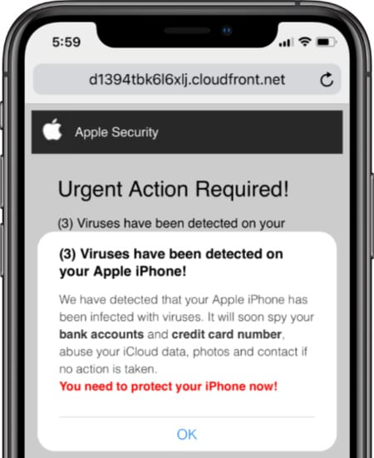

# **Jailbreak Pros**

There are 4 main pros that I found most noteworthy for this handbook when it comes to jailbreaking an IOS Device. These four pros include the ability to download apps from anywhere, alternative app use, special customization of IOS Devices, and the removal of pre-installed apps.

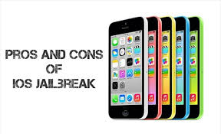

## Download and Use of Third-Party Apps

This is probably the number one reason most people jailbreak their IOS device. When you jailbreak your iPhone, iPad, or iPod Touch, you are now enabled with the power to install and actually use applications you would not normally be able to use or even access period.

The main gateway for this is the software called Cydia. With this app, you can access almost any third-party app legally.

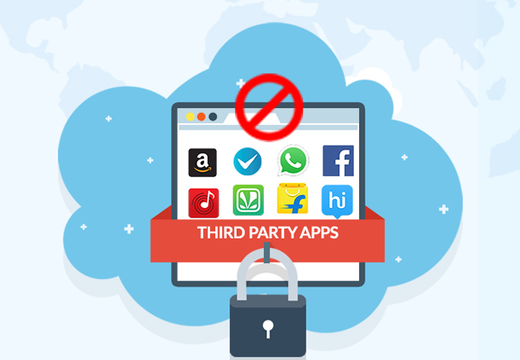

## Cross Compatible File Sharing

Now what does cross compatible file sharing mean exactly? Well, for this instance, it means once you jailbreak your iPhone operating system, you are now able to file share an Apple device with a Samsung or HP device. For example, an iPhone would now be enabled to share files digitally with an Android.

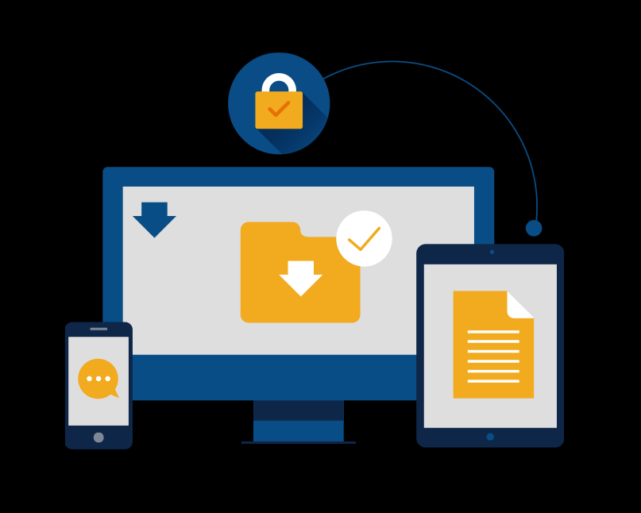

## Special Customization of IOS Device

There are many special customization options that the IOS user is prompted the ability to do, for jailbreaking these particular devices opens up a whole new custom world for IOS users. A new feature you would be able to do includes unique customization to the control center like adding more toggles and shortcuts to the CC. Another really cool attribute would be the ability to specially customize icons and add boot animations within the device.

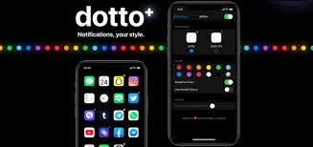

## Remove Pre-Installed Apps

This feature allows numerous satisfaction to the user, because they are now simply enabled to delete those default apps on their device that they never used and just took up space. Apple has had many complaints about not being able to remove default apps, but now there is a way that allows a user to do so.

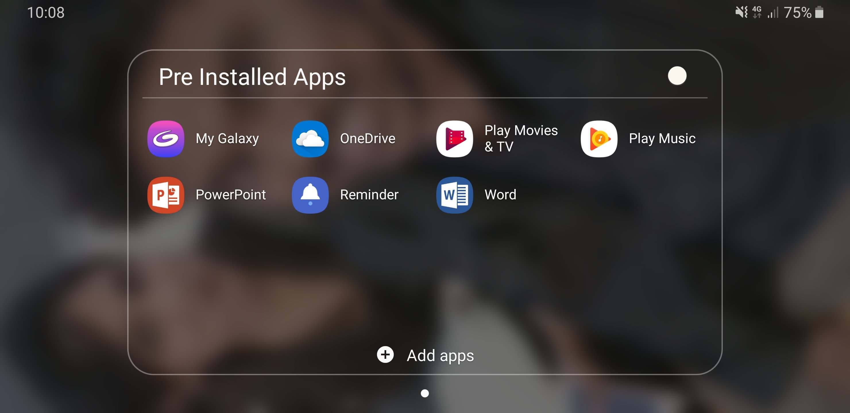

# **Jailbreak Cons**

In my opinion, the cons unanimously outweigh the pros. Hence, there are 6 main cons that I found most noteworthy for this handbook when it comes to jailbreaking an IOS Device. These six cons include the invalidation of an IOS warranty, Apple’s software security is terminated, the inability to update the IOS Device, drained battery life, increased device crash rate, and the disruption of services.



## Invalidate iPhone Warranty

Using jailbreaking methods like installing unauthorized software or hampering with Apple Software on IOS Devices is a direct violation to the OS end-user software license agreement. Because of this, Apple is allowed to deny any service of an IOS user who has jailbroken their device.

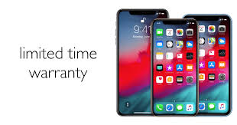

## Apple’s Software Security Terminated

Many security layers, if not all, have been tarnished because of the jailbreak procedure that takes place. During a jailbreak, it removes all Apple protection from your device, for malware is now able to infect and corrupt your device. Your IOS Device is now at major risk of getting severely hacked and personal information is in danger of being stolen.



## Inability to Update IOS Device

After an IOS Device has been jailbroken, you can no longer update your software again. The only way you can receive IOS update’s again is if you actually undo the jailbreak and proceed your device back to normal.

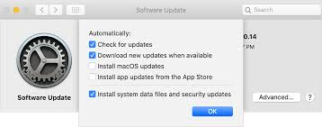

## Drained Battery Life

Once jailbroken, the battery life of your IOS device is significantly compromised and can’t hold a stable charge. This occurs because the new jailbroken software constantly drains battery at an amplified rate due to its’ enhanced power.

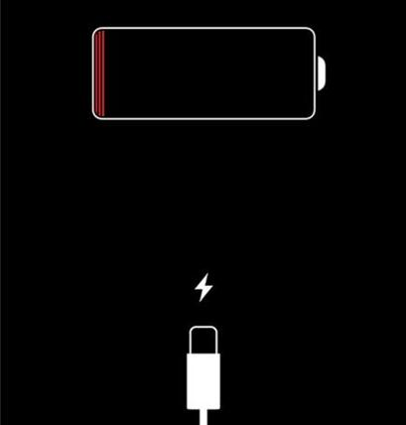

## Increased Device Crash Rate

Because jailbreaking an IOS Device takes away all Apple security protection, malware is openly transmitted into your software and there is nothing there to stop it from infecting your device with all kinds of viruses. Furthermore, this introduces a variety of bugs within the device and because of that it swiftly increases application crashes. Ultimately, your IOS system is at risk of crashing way more often than not.

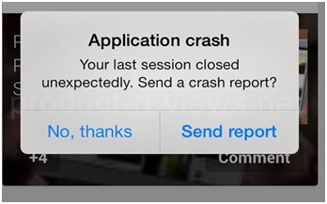

## Disruption of Services

Many Apple respected features and services may no longer work due to the new, foreign installed software caused by the jailbreaking process. These services may include, iMessage, Face Time, Apple Pay, etc. All your iCloud data could also be compromised.

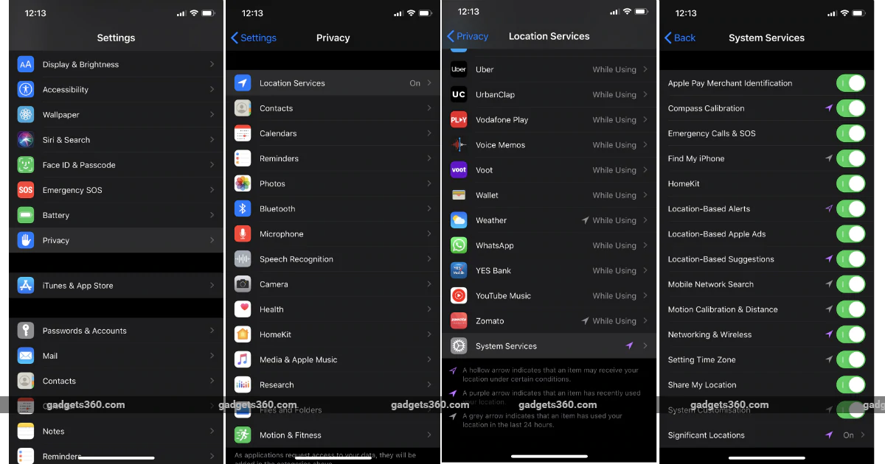

# **Jailbreak Instructions**

(JAILBREAK AT YOUR OWN RISK)

There are many risks and a large, harmful gray area when jailbreaking your device, for I would not advise someone to do it unless they know exactly what they are truly getting their self into. In order to jailbreak your IOS system you will need to download and install special, particular software depending on the variation of your IOS Device. Below I have listed each software correlated to each IOS version that is required to jailbreak from IOS 6 and up (<https://www.iphonehacks.com/jailbreak>):

|  |  |  |  |  |  |
| --- | --- | --- | --- | --- | --- |
| **iPhone Model** | **Apple Chip** | **Jailbreak Available?** | **iOS Version Supported** | **iOS Version Not Supported** | **Jailbreak Tool** |
| iPhone 11, iPhone 11 Pro, iPhone 11 Pro Max, iPhone SE (2020) | A13 Chip | Yes | iOS 13 – iOS 13.5 | iOS 13.5.1 | Unc0ver Jailbreak |
| iPhone XS, iPhone XS Max, iPhone XR | A12 Chip | Yes | iOS 12 – iOS 13.5 | iOS 13.5.1 | Unc0ver Jailbreak |
| iPhone X, iPhone 8, iPhone 8 Plus | A11 Bionic Chip | Yes | iOS 11 – iOS 13.5 | iOS 13.5.1 | Unc0ver Jailbreak |
| iPhone 7, iPhone 7 Plus | A10 Chip | Yes | iOS 10 – iOS 13.4.1 | iOS 10.2.1 – iOS 10.3.4 | iOS 11 – iOS 13.5:  Unc0ver Jailbreak  iOS 10 – iOS 10.3.4:  Yalu Jailbreak |
| iPhone 6s, iPhone 6s Plus, iPhone SE (2016) | A9 Chip | Yes | iOS 9 – iOS 13.4.1 | – | iOS 11 – iOS 13.5:  Unc0ver Jailbreak  iOS 11 – iOS 11.4.1:  Electra Jailbreak  iOS 10 – iOS 10.3.4:  Yalu Jailbreak  iOS 9 – iOS 9.3.3:  Pangu9 Jailbreak |
| iPhone 6, iPhone 6 Plus | A8 Chip | Yes | iOS 8 – iOS 12.4.4 | iOS 12.4.2 – iOS 12.4.4 | iOS 11 – iOS 12.4.1:  Unc0ver Jailbreak  iOS 11 – iOS 11.4.1:  Electra Jailbreak  iOS 10 – iOS 10.3.4:  Yalu Jailbreak  iOS 9 – iOS 9.3.3:  Pangu9 Jailbreak  iOS 8 – iOS 8.1:  Pangu8 Jailbreak |
| iPhone 5s, iPhone 5C | A7 Chip | Yes | iOS 7 – iOS 12.4.4 | iOS 12.4.2 – iOS 12.4.4 | iOS 11 – iOS 12.4.1:  Unc0ver Jailbreak  iOS 11 – iOS 11.4.1:  Electra Jailbreak  iOS 10 – iOS 10.3.4:  Yalu Jailbreak  iOS 9 – iOS 9.3.3:  Pangu9 Jailbreak  iOS 8 – iOS 8.1:  Pangu8 Jailbreak  iOS 7 – iOS 7.1.2:  Pangu Jailbreak |
| iPhone 5 | A6 Chip | Yes | iOS 6 – iOS 10.3.4 | – | iOS 10 – iOS 10.3.4:  Yalu Jailbreak  iOS 9 – iOS 9.3.3:  Pangu9 Jailbreak  iOS 8 – iOS 8.1:  Pangu8 Jailbreak  iOS 7 – iOS 7.1.2:  Pangu Jailbreak  iOS 6 – iOS 6.1.6:  Redsn0w |

## Step by Step Guide

Website Domain: (<https://lifehacker.com/how-to-jailbreak-your-ios-13-5-device-1843683045>)

**Step 1**

Gather your IOS Devices & install AltStore

**Step 2**

1. Launch Safari and go to unc0ver.dev
2. Tap “Open in Alt Store,” then tap “Open.”
3. Enter your Apple ID and Apple ID password when prompted by the AltStore installation page, then wait for Unc0ver to download.
4. Tap “7 Days” to install the jailbreak tool.
5. Open Unc0ver from your iPhone’s home screen, then tap “Jailbreak.”
6. Wait for the process to complete and for your iPhone to reboot.
7. Launch Unc0ver once more and tap “Jailbreak” again, and our device will reboot one more time.

**Step 3**

Launch the Cydia App from your IOS home screen.

Your IOS Device has now been successfully jailbroken!!

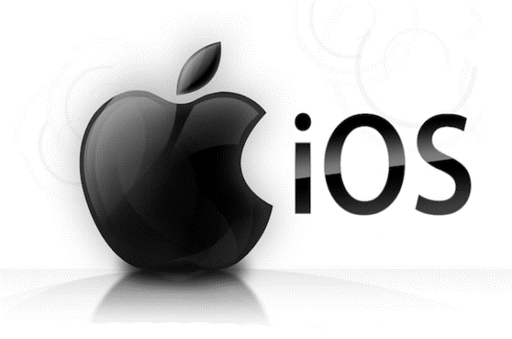

## YouTube Attachment

I will also provide an updated YouTube tutorial step by step jail break guide for those that are truly inexperienced and beginners to IOS jailbreaking. Although this is not my tutorial, it is

9to5Mac’s You Tube Tutorial, it is a great video that breaks down each step of the jailbreak process and gives an excellent visual of how it is properly done.

Link: <https://www.youtube.com/watch?v=pN-OazsEcEQ>

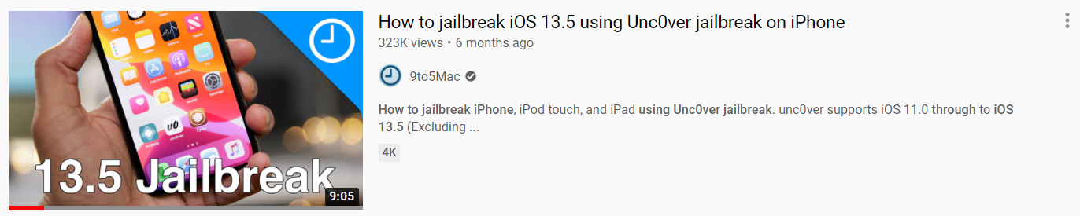

# **Conclusion**

In conclusion, the IOS jailbreak is an extremely exhilarating and thrilling process that satisfies multiple users who like to playfully “hack” devices. Although jailbreaking is such an extraordinary aspect within the IOS Device culture, it is very risky and dangerous to the device’s software and security. Moreover, Jailbreaking is a high-risk high reward action. There are so many amazing things you can do with a jailbroken IOS Device, but it is exposed to so many harmful malware and is prone to errors in the future. Personally, I would not jailbreak my device, for I have done it before and have experienced a handful of issues post jailbreak. I would also not recommend you jailbreak any of your IOS Devices until you do your research and know the cause and effects it may have on your device’s future. Hopefully this handbook was a very helpful resource and guide to help you confirm your decision before jailbreaking any IOS Device.

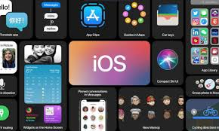

# **References**

“Disadvantages & Benefits of Jailbreaking IOS.” *Should I Jailbreak My IPhone? Reasons to or Not to Jailbreak IPhone, IPad, IPod*, Anvsoft Inc, Retrieved November 28, 2020, from [www.syncios.com/iphone/should-i-jailbreak-my-iphone.html](http://www.syncios.com/iphone/should-i-jailbreak-my-iphone.html).

Heath, Alex. “The History Of Jailbreaking [Feature].” Cult of Mac, 27 July 2015, Retrieved November 28, 2020, from

[www.cultofmac.com/192850/the-history-of-jailbreaking-feature/](http://www.cultofmac.com/192850/the-history-of-jailbreaking-feature/).

“How to Jailbreak IPhone, IPad and IPod Touch.” *IPhone Hacks | #1 IPhone, IPad, IOS Blog*, Blog Consulting, 7 June 2020, Retrieved November 28, 2020, from [www.iphonehacks.com/jailbreak](http://www.iphonehacks.com/jailbreak).

“Jailbreak: What Is Involved in Advanced User Access to IOS Devices?” *IONOS Digitalguide*, 1 & 1 IONOS Inc, 2 Mar. 2020, Retrieved November 28, 2020, from [www.ionos.com/digitalguide/websites/web-development/jailbreak-ios/](http://www.ionos.com/digitalguide/websites/web-development/jailbreak-ios/).

Johansen, Alison Grace. “Is Jailbreaking Legal and Safe?” *Norton*, NortonLifeLockInc, 22 Mar. 2019, Retrieved November 28, 2020, from

[us.norton.com/internetsecurity-mobile-is-jailbreaking-legal-and-safe.html](http://us.norton.com/internetsecurity-mobile-is-jailbreaking-legal-and-safe.html).

Mead-Green, Rob. “The Pros and Cons of IPhone Jailbreaking.” *Macworld UK*, IDG, 27 Feb. 2018, Retrieved November 28, 2020, from

[www.macworld.co.uk/feature/is-jailbreaking-my-iphone-or-ipad-safe-3491721/](http://www.macworld.co.uk/feature/is-jailbreaking-my-iphone-or-ipad-safe-3491721/).

Nazario, Kyle. “An Introduction to Jailbreaking for Total Beginners.” *TechNorms*, TechNorms, 27 Feb. 2019, Retrieved November 28, 2020, from

[www.technorms.com/11357/introduction-jailbreaking-total-beginners](http://www.technorms.com/11357/introduction-jailbreaking-total-beginners).

Sachdeva, Anmol. “What Is Jailbreaking? Is Jailbreaking An IPhone Illegal?” *Fossbytes*, Fossbyte Media Pvt Ltd, 14 Dec. 2018, Retrieved November 28, 2020, from [fossbytes.com/what-is-jailbreaking-iphone-illegal/](http://fossbytes.com/what-is-jailbreaking-iphone-illegal/).

“Unauthorized Modification of IOS Can Cause Security Vulnerabilities, Instability, Shortened Battery Life, and Other Issues.” *Apple Support*, Apple Inc, 15 June 2018, Retrieved November 28, 2020, from [support.apple.com/en-us/HT201954](http://support.apple.com/en-us/HT201954).

YouTube Tutorial by 9to5Mac’s, Retrieved November 28, 2020, from

<https://www.youtube.com/watch?v=pN-OazsEcEQ>